How to add a Can Too frame on my Facebook Profile Pic on my computer

1.Click on your profile pic
2. Choose ‘Update Profile Picture’

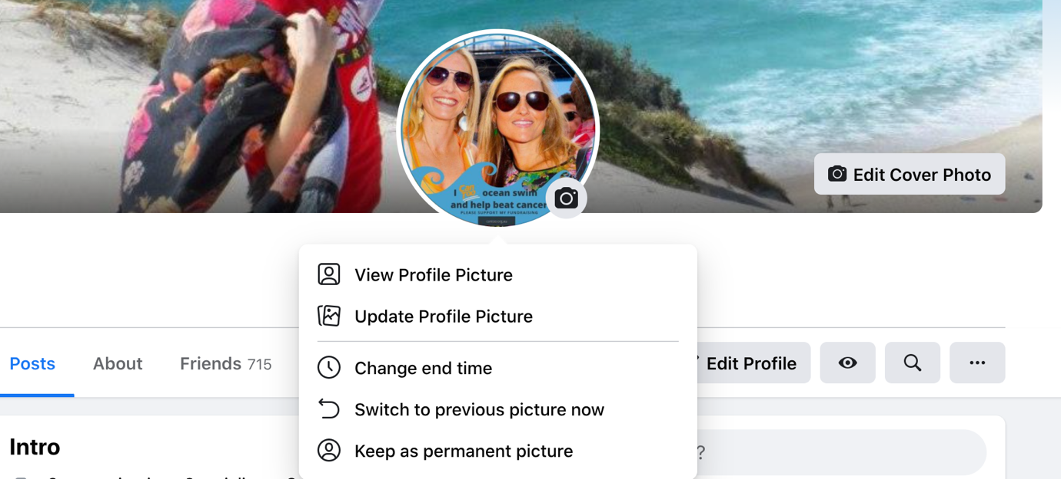

3. select: "add frame"

4.
type in search field under choose a frame: "I can Too .... (type 'run a marathon', 'run a half marathon' or 'ocean swim')
And select the relevant frame

5.
set the ‘duration’ e.g 1 month, ‘custom’ or ‘never’
then click ‘use as profile picture’

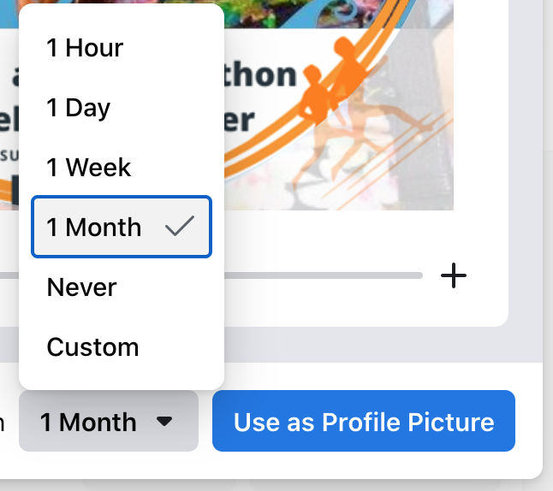

6. a post will automatically appear in your news feed
edit this post to add a message and include your fundraising page link

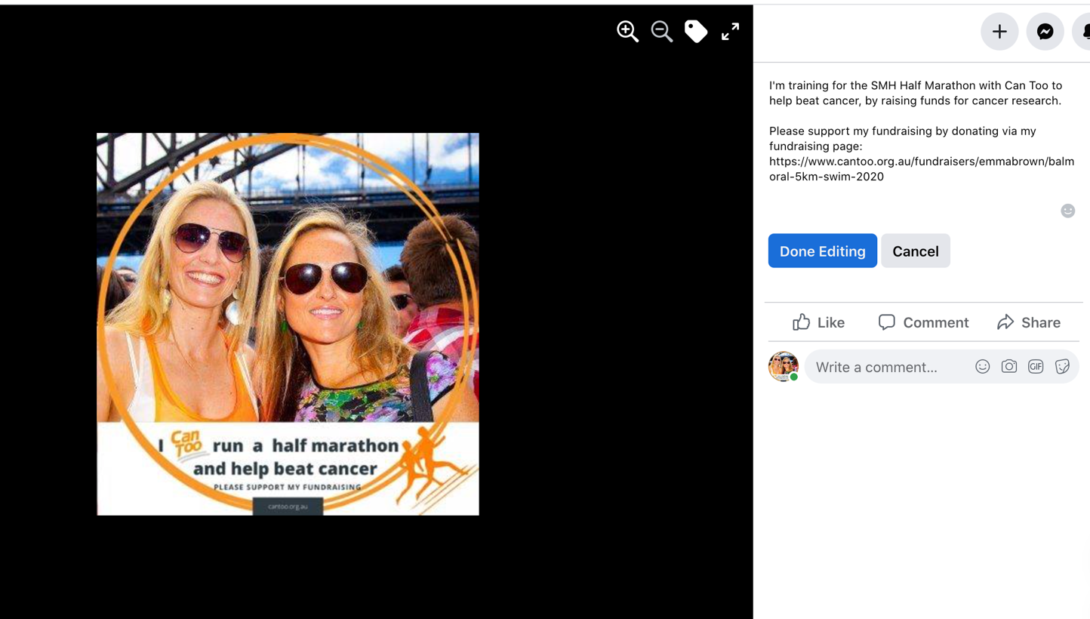

Please note if you want to switch back to your previous profile picture or update to a new frame.
You need to upload your previous profile picture withouth the frame, which will appear in the options to choose from. So you start with a profile picture without a frame so one frame doesn’t appear on top of the other one.

Any questions please email: info@cantoo.org.au

